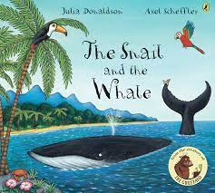
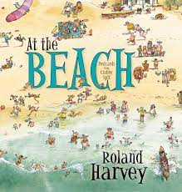
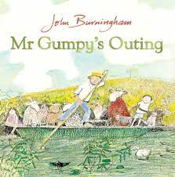
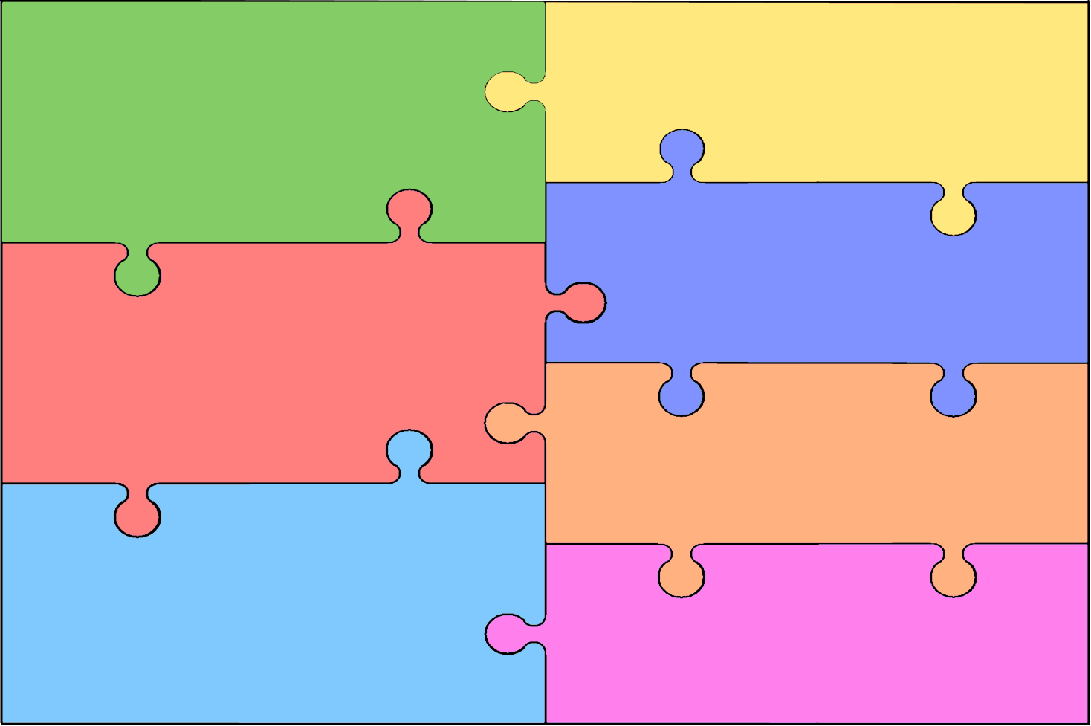
Literacy: Word Reading, Comprehension and writing
How can we use our phonic knowledge to create sentences, postcards and recount stories?
- Talk for writing using Jaspers Bean stalk,
- Daily phonic sessions to include segmenting and blending for
writing and reading as well as daily reading groups.
- Fiction and non-fiction books linked to the topic including ‘That’s not my…’ story series including ‘That’s not my penguin!’.
- Instruction writing - How to grow cress or a bean.
- Writing postcards from America using Bearamy Bear’s Postcards.
- Exploring a wide range of fiction and non-fiction texts linked to our topic including: At The Beach; My Boomerang Won’t Come Back; Sharing a Shell; The Snail and The Whale, What The Ladybird Heard At The Beach; Mr Gumpy’s Outing and Barry The Fish With Fingers.

Personal, Social and Emotional Development
- Transition – start to prepare the child for change, visit new year group and meet significant adults. What are we looking forward to? What are our worries?
- How can we keep safe online?
- Through ‘circle time’, opportunities to listen to views of others and express and share feelings.
- What is honesty? Exploring our whole school values.
- Demonstrating perseverance in the face of a challenge
PSHE – Jigsaw: ‘Changing Me’
- My body
- Respecting my body
- Growing up
- Fun and fears
- Celebration

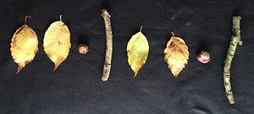
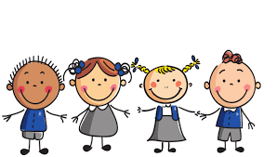
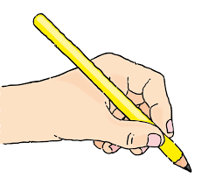
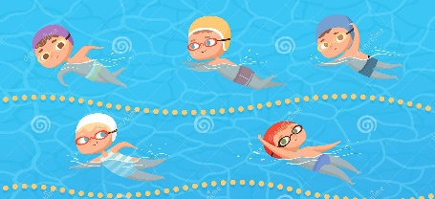
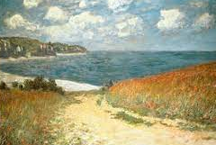
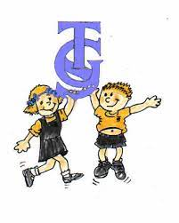
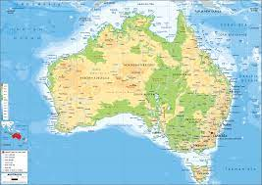
Mathematics
- Subitising
- continue to identify when sets can be subitised and when counting is necessary
- develop conceptual subitising skills including when using a rekenrek
- Understanding of numbers to 10
- Number bonds to 5 and then 10
- Subtraction facts to 5 and then 10
- Addition facts to 5 and then 10
- Exploring the composition of numbers
- Counting beyond 20
- Comparing and ordering numbers and amounts

Being Imaginative and Expressive
- Performing in class end of year performance/assembly
- Learning about music from Australia – both traditional and modern.
- Singing songs from memory
- Appraising pieces of music
- Sing in a group or on their own
- Move in response to music
Creating with materials
- Collaborative art
- Artwork based on the illustrations of ‘The Rainbow Fish’
- Famous artists and beach scenes – Monet and Picasso

- Celebration – Father’s Day
- People who help us in school and the wider community. .
- Practise and use past, present and future forms accurately when talking about events that have happened or are to happen in the future.
- To be able to speak clearly and confidently in a range of situations.

- Developing an awareness of the features of non-fiction texts linked to our topic.
- Writing a recount – local walk and trip to the Lookout Discovery centre.
- Using non-fiction to explore people who help us
- Writing ‘Our memories of Reception’
- Writing opportunities in all areas of learning both inside and outside.

- Compare weight, length and capacity
- Exploring money
- Repeating patterns
- Identifying shapes within shapes
- Numerical patterns
- Looking for patterns in nature

Understanding The World
Past and Present, People, Countries and communities
- Exploring maps – linked to our postcards from Bearamy Bear. Map of local area to locate school and Windsor Castle.
- Maps of North America, the UK and the world.
- RE - Specialness: What makes our world wonderful?
- Our school and it’s place in the local community
- What’s the weather like? Comparing life in the UK to North America.

- Swimming – learning to use the pool confidently.
- Awareness of body changes during exercise.
- Negotiate space and obstacles safely, with consideration for themselves and others;
- Demonstrate strength, balance and coordination when playing;
- Move energetically, such as running, jumping, dancing, hopping, skipping and climbing.
- Managing own hygiene and personal need. How can we stay safe from the sun?

Physical Development
- Developing fine motor control through using tweezers, threading and pegs, scissors and writing materials
- Developing correct pencil grip and starting to form letters correctly.
- Developing sentence writing using correct formation.
- Scissor skills to cut accurately different shapes
- Handling equipment and tools, including for writing, cutting and making
- Healthy eating and promoting playtime fruit and use of water bottles.

Communication and Language
Listen & Attention and speaking
- Practise for, and perform in, end of year class assembly
- To be able to describe events in detail.
- Talking about and answering questions about individual, group and whole class learning experiences.

