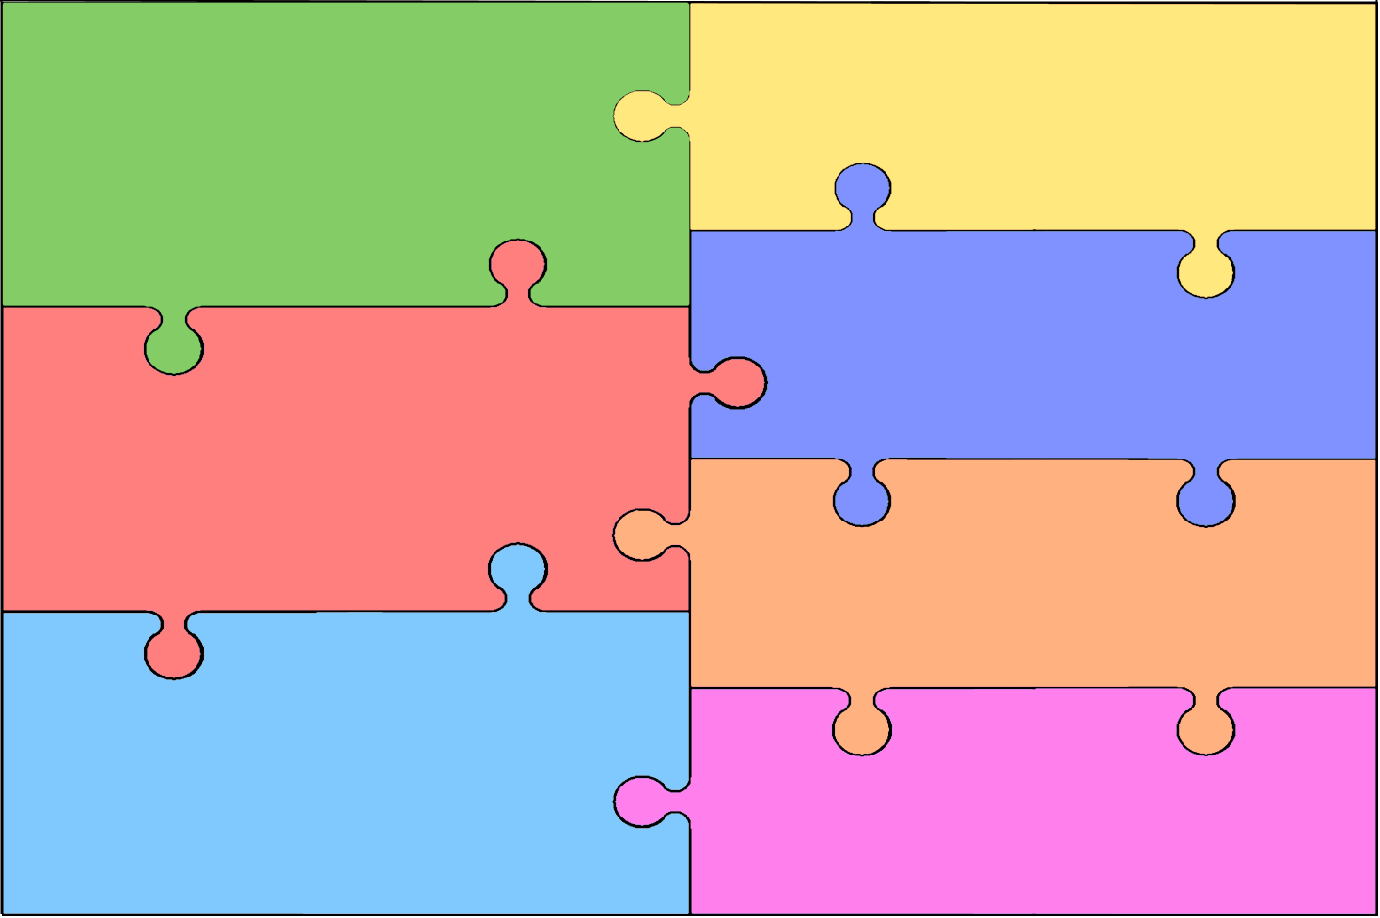
Literacy: Word Reading, Comprehension and writing
How can we use our phonic knowledge to create simple sentences, labels, captions and
- Read and share stories by Eric Carle including The Very Hungry
Caterpillar and the Bad Tempered Ladybird, The Tiny Seed
- Orally retell with actions
- Pictorially retell with key words/ initial sounds/
CVC words
- Use text maps to write the story
- Innovate text
- Daily phonic sessions to include segmenting and blending for
writing and reading
- Writing labels, captions and simple sentences linked to our topics

Personal, Social and Emotional Development
- Transition – start to prepare the child for change, visit new year group and meet significant adults
- Through ‘circle time’, opportunities to listen to views of others and express and share feelings.
- Exploring our whole school values of trust cooperation, tolerance, appreciation
- Demonstrating perseverance in the face of a challenge

PSHE – Jigsaw: Relationships
- My family and me
- Make friends make friends never ever break friends
- Falling out and bullying
- Being the best friends we can be

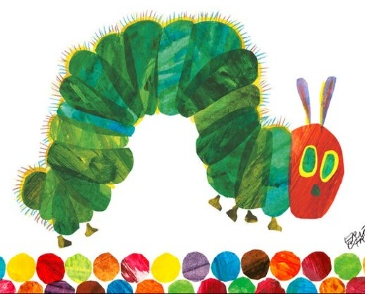
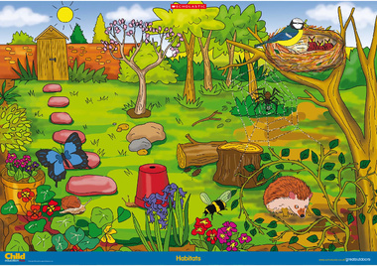
- Read non fiction texts linked to Minibeasts. Where in the library will we find books about Minbeasts?
- Developing fine motor control, letter and number formation
- Developing an awareness of the features of non-fiction texts linked to our topic.
- Fiction and non-fiction books linked to the topic including Jaspers Bean stalk,
- Instruction writing - How to grow cress or a bean.
- Write in full sentences.
- Using non-fiction language in our writing
- Writing opportunities in all areas of learning both inside and outside.

Mathematics
- Cardinality, counting, ordinality -
continue to develop their counting skills, counting larger sets as well as counting actions and sounds

- Subitising using doubles –
explore a range of representations of numbers, including the 10-frame, and see how doubles can be arranged in a 10-frame

- Composition of numbers 1-10
continue to develop a sense of magnitude, e.g. knowing that 8 is quite a lot more than 2, but 4 is only a little bit more than 2

- Saying one number for each item
- Linking numerals and amounts up to 5
- Number bonds to 5 and then 10
- Comparison of numbers to 10
- Subtraction facts to 5
- Solving mathematical problems with numbers up to 5 and then 10
- Use own symbols and marks begin to use mathematical symbols when problem solving and recording
- Compare weight, length and capacity
- Extend spatial reasoning skills – e.g. with construction, tessellating shapes.
- Compose and decompose shapes to allow children to recognise that shapes can have other shapes within them.
- Explore and represent patterns within numbers up to 10
- Sharing equally
Understanding The World
Past and Present, People, Countries and communities
- What do we know about growth and living things? What do we want to find out?
- What is an insect? Is a spider an insect?
- Using the iPad to record learning and share with others
- Do spiders have the same body parts as a ladybird?
- Going on a minibeast hunt. Where in the school environment will we find them?
- RE- Specialness and belonging. What makes a place special?

- Caring for our environment including living things.
- Planting seeds could include beans and cress. What will they need to grow and survive?
- Make a bean coasters
- Technology – using ipads, class desk tops & IWB
- Our local community – where is Windsor castle? Can we find it on a map? How close is it our school?

- Awareness of body changes during exercise.
- Gym activities to include curling and stretching, tall and wide, high and low movements, travelling in a variety of ways.
- Negotiate space and obstacles safely, with consideration for themselves and others;
- Demonstrate strength, balance and coordination when playing;
- Move energetically, such as running, jumping, dancing, hopping, skipping and climbing.
- Healthy eating and promoting playtime fruit and use of class water bottles.
- Managing their own hygiene and personal needs

Physical Development
- Developing fine motor control through using tweezers, threading and pegs
- Developing correct pencil grip and starting to form letters correctly.
- Writing name using correct formation.
- Scissor skills to cut accurately different shapes
- Awareness of body changes during exercise.
- Warm up and cool down routines in PE
- Finding spaces and moving safely within the space.
- Handling and using apparatus safely.
- Developing control and coordination of movement
- Handling equipment and tools, including for writing, cutting and making
- Learning about healthy diet and exercise

Expressive Arts and Design Being Imaginative and Expressive and Creating with materials
Printing with 3D shapes, soft and hard materials
Role play experiences to include school, gardens and mini beast lab
Art in the style of Eric Carle
Naming and exploring instruments. Repeating a rhythm and keeping beat
Performing in class end of year performance/assembly
Music – learn the songs Happy Sun High, The seed song
Dance – exploring movement to match a theme or piece of music.

Communication and Language
Listen & Attention and speaking
- Listen and respond to rhymes and stories.
- Listen and respond to others in pairs and small groups.
- Using language to recreate roles and experiences.
- Talking about and answering questions about individual, group and whole class learning experiences.

- Listen attentively in a range of situations.
- Listen to stories, accurately anticipating key events and
respond to what they hear with relevant comments, questions
or actions.
- Listens and responds to ideas expressed by others in conversation or discussion.
- Follow instructions involving several ideas or actions.
- Practise and use past, present and future forms accurately when talking about events that have happened or are to happen in the future.

